**THE FUTURE OF WORK – Reading : Finkel’s Law: robots won’t replace us because we still need that human touch**

By now, you’ve probably been warned that a robot is coming for your job. But rather than repeat the warning, I’ve decided to throw downa challenge: man against machine.

First, I’ll imagine the best possible robot version of an Australian Chief Scientist that technologists could build, based on the technologies available today or in the foreseeable future. Call it “ChiefBot”. Then I’ll try to persuade you that humanity still has the **competitive edge**. Let’s begin with the basic tasks our ChiefBot would be required to do.

First, deliver speeches. Easy. There are hundreds of free text-to-voice programs that wouldn’t cost the taxpayer a cent.

Second, write speeches. Again, easy. Google has an artificial intelligence (AI) system that writes poetry. A novel by a robot was shortlisted in a Japanese literary competition. Surely speeches can’t be so hard.

Third, scan the science landscape and identify trends. Watson, developed by IBM, can already do it. Watson is not just history’s most famous *Jeopardy!* champion: he’s had more careers than Barbie, from **talent scouting** for professional sport to **scanning** millions of pages of scientific reports to diagnose and treat disease.

Fourth, and finally: serve on boards and make complex decisions.

ChiefBot wouldn’t be the first robot to serve in that capacity. For example, an Australian company now sells AI software that can advise company boards on financial services. There’s a company in Hong Kong that has gone one step further and actually **appointed** an algorithm as a director.

So, there’s ChiefBot. I admit he’s pretty good. We have to assume that he will capture all the benefits of ever-advancing upgrades – unlike me.

But let’s not abandon our faith in humanity without looking again at the selection criteria for the job, and the capabilities on the human **resume**.

**Man vs machine**

Start with the task we’re engaged in right now: communicating in **fluent** human. We’re sharing abstract ideas through words that we choose with an understanding of their nuance and impact. We don’t just speak in human, we speak as humans.

A robot that says that science is fun is delivering a line. A human who says that science is fun is telling you something important about being alive. That’s knowledge that ChiefBot will never have, and the essence of the Chief Scientist’s job. **Chalk** that **up** to Team Human.

Here’s another inbuilt advantage we take for granted: as humans we are limited by design. We are **bound** in time: we die. We are bound in space: we can’t be in more than one place at a time. That means that when I speak to an audience, I am giving them something exclusive: a **chunk** of my time. It’s a **custom-made**, **one-off**, 100% robot-free delivery, from today’s one-and-only Australian Chief Scientist. True, I now come in digital versions, through Twitter and Facebook and other platforms, but the availability of those tools hasn’t stopped people from inviting me to speak in person. Digital Alan seems to increase the appetite for human Alan, just as Spotify can boost the demand for a musician’s live performances.

We see the same pattern repeated across the economy. Thanks to technology, many goods and services are cheaper, better and more accessible than ever before. We like our mass-produced bread, and our **on-tap** lectures and our automated FitBit advice.

But automation hasn’t killed the artisan bakery. Online courses haven’t killed the **bricks-and-mortar** university. FitBit hasn’t killed the personal trainer. On the contrary, they’re all booming, alongside their machine equivalents.

**Finkel’s Law**

Call it Finkel’s Law: where there’s a robot, we’ll see renewed appreciation for the humans in the robot-free zone. Team Human, two goals up.

Let me suggest a third advantage: you and I can be flexible and effective in human settings. In our world, AI are the **interlopers**. We are the **incumbents**. It’s the robots who have to make sense of us. And we make it extraordinarily hard.

Think, for example, of a **real estate** negotiation. We could rationalise it as an exchange of one economic **asset** for another. In reality, we know that our actions will be **swayed** by sentiment, insecurity and **peer pressure**.

In that **swirl** of reason and emotion, the art of the real estate agent is to anticipate, pivot and **nudge**.

The human real estate agent is the package deal. She can **harness** AI to sharpen her perceptions and overcome cognitive **bias**es. Then she can hit the human buttons to flatter, **deflect** or persuade.

That human touch is hard to replicate, and even harder to reduce to a formula and scale. Team Human, three goals to nil.

Here’s a fourth argument for the win. We humans have learned the habit of civilisation. Let me illustrate this point by a story.

**The human future**

A few years ago, some researchers **set out** to investigate the way that people interact with robots. They sent out a small robot to patrol the local mall. That robot had a terrible time – and the villains of the story were children. They kicked him, bullied him, smacked him in the head and called him a string of indelicate names. The point is not that the children were violent. The point is that the adults were not. They restrained whatever primitive impulse they might have felt in childhood to smack something smaller and weaker in the head, because they had absorbed the habit of living together. We call it civilisation.

If we want artificial intelligence for the people, of the people and by the people, we’ll need every bit of that civilising instinct we’ve **hone**dover thousands of years. We’ll need humans to **tame** the machines to our human ends. I’d say that’s Team Human, in a **walkover**.

Together, these points suggest to me that humanity has a powerful competitive edge. We can coexist with our increasingly capable machines and we can make space for the full **breadth** of human talents to flourish.

But if we want that future – that human future – we have to want it, claim it and own it. Take it from a human Chief Scientist: we’re worth it.

*This article is based on a speech Alan Finkel, Australia’s Chief Scientist, delivered to the Institute of Electrical and Electronics Engineers (IEEE) international conference in Sydney earlier this month. Published in* [*The Conversation*](https://theconversation.com/finkels-law-robots-wont-replace-us-because-we-still-need-that-human-touch-82814)

**1. Vocabulary: Read the text and match each word or phrase in bold with the corresponding definition below:**

a. to have or record something good or bad:

b. looking for people who have the skills wanted, especially in entertainment or sports:

c. person who has or had a particular official position:

d. to choose someone officially for a job or responsibility:

e. the strong influence of a group on members of that group to behave as everyone else does:

f. something that happens or is made or done only once:

g. the fact that a company has an advantage over its competitors:

h. limited because depending on (but can also mean certain or extremely likely to happen):

i. a part of something, especially a large part:

j. spoken easily and without many pauses:

k. specially made for a particular person:

l. that starts or stops when touching the screen:

m. to develop and improve something, especially a skill, over a period of time:

n. someone who becomes involved in an activity or a social group without being asked, or enters a place without permission:

o. to look through a text quickly in order to find a piece of information that you want or to get a general idea of what the text contains:

p. an easy victory in a game or competition:

q. to cause something to move or change:

r. a CV:

s. a twisting, circular movement, or something that moves in this way:

t. something valuable belonging to a person or organization that can be used for the payment of debts (but also a useful or valuable quality, skill, or person):

u. to cause something to change direction, or to suddenly go in a different direction:

v. an unfair personal opinion that influences your judgment:

w. to control something, usually in order to use its power:

x. to start an activity with a particular aim:

y. real buildings as opposed to digital entities:

z. to make sg or an animal less powerful or easier to control:

aa. to push something or someone gently, to push someone with your elbow:

bb. width, a wide range:

cc. property in the form of land or buildings:

**2. Get ready to answer questions during the interview. Make sure you have taken notes on:**

Chiefbot, all the differences between humans and robots, why humans are still useful when robots are doing similar tasks, the real estate transactions, the definition of civilisation.

**3. Grammar: Relative clauses**

The text is the script of a speech. This is the reason why which (relative pronoun) is rarely used. That is used instead. However, there is a difference between which and that:

"which" introduces a non-essential clause, meaning that it doesn't define the noun it's describing, while "that" introduces an essential clause, meaning that it clarifies exactly which noun the sentence is about. For example, the following two sentences are both correct:

*My house,* ***which*** *I bought recently, is next to a lake.*

*The house* ***that*** *I bought recently is next to a lake.*

In the first sentence the relative clause "which I bought recently" is further describing "my house." In the second, the clause "that I bought recently" is specifying which house the sentence is about.

Read the grammar below and do the exercises:

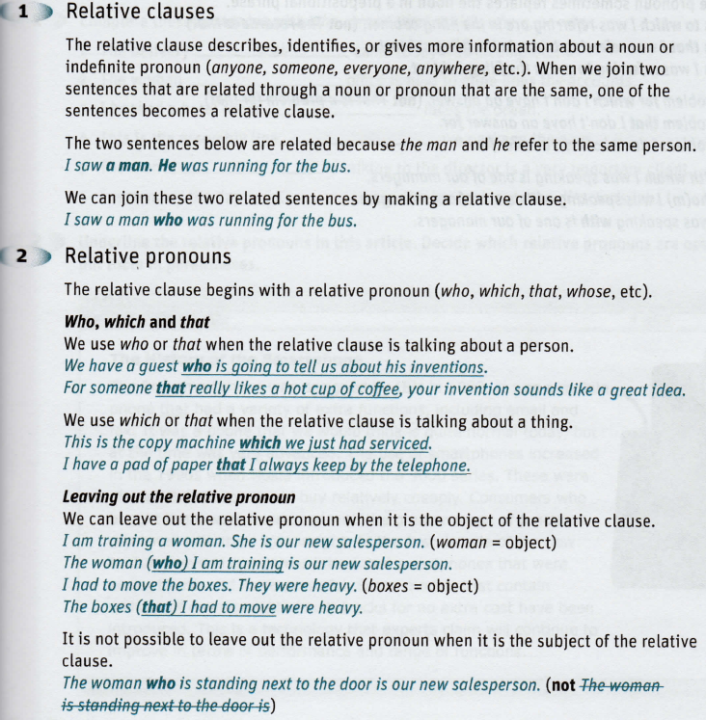

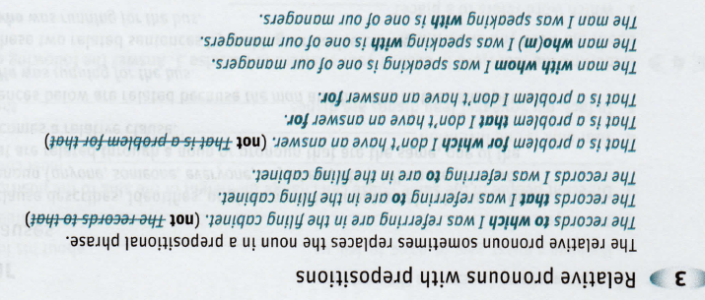

Exercise 1:

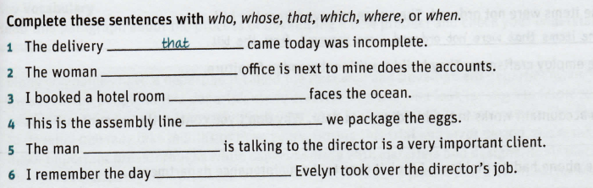

Exercise 2:

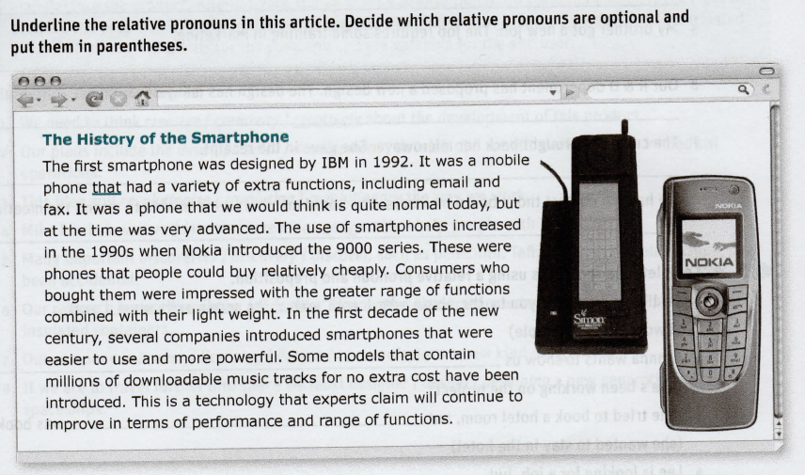

Exercise 3:

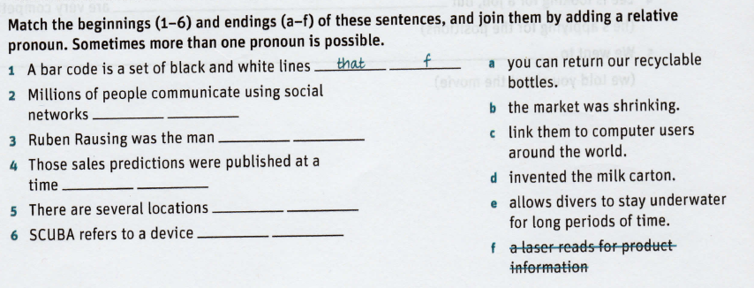

Exercise 4

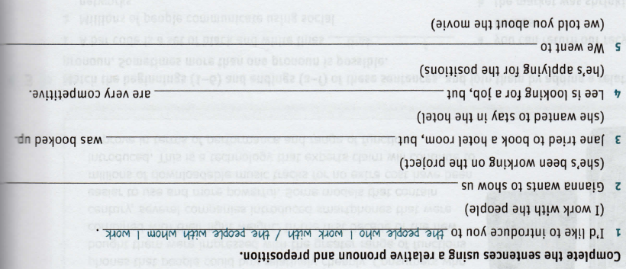

Exercise 5:

